**Set up tns connections between two machine.**

**ArcSDE**

## 

Oracle Sql Developer

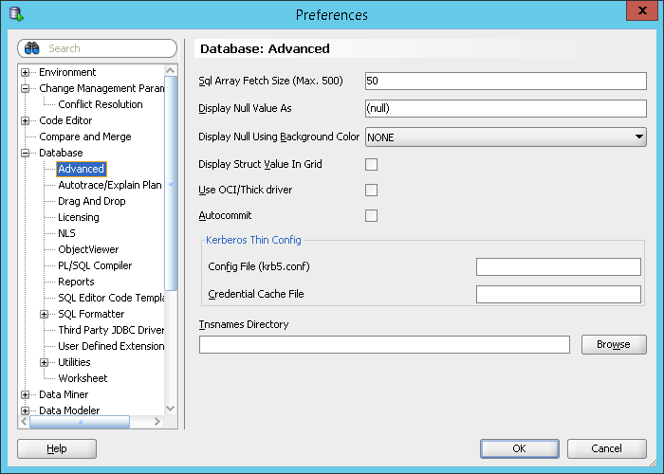\

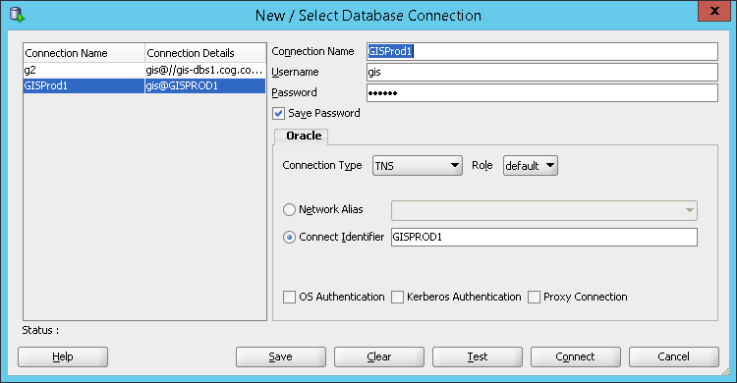

TNS NAME FILE

C:\oracle\product\11.2.0\**client_1\network\admin**

GEOPROD1 =

(DESCRIPTION =

(ADDRESS_LIST =

(ADDRESS = (PROTOCOL = TCP)(Host = gis-dbs1.cog.coggov.local)(Port = 1521))

)

(CONNECT_DATA =

(SID = geoprod1)

)

)